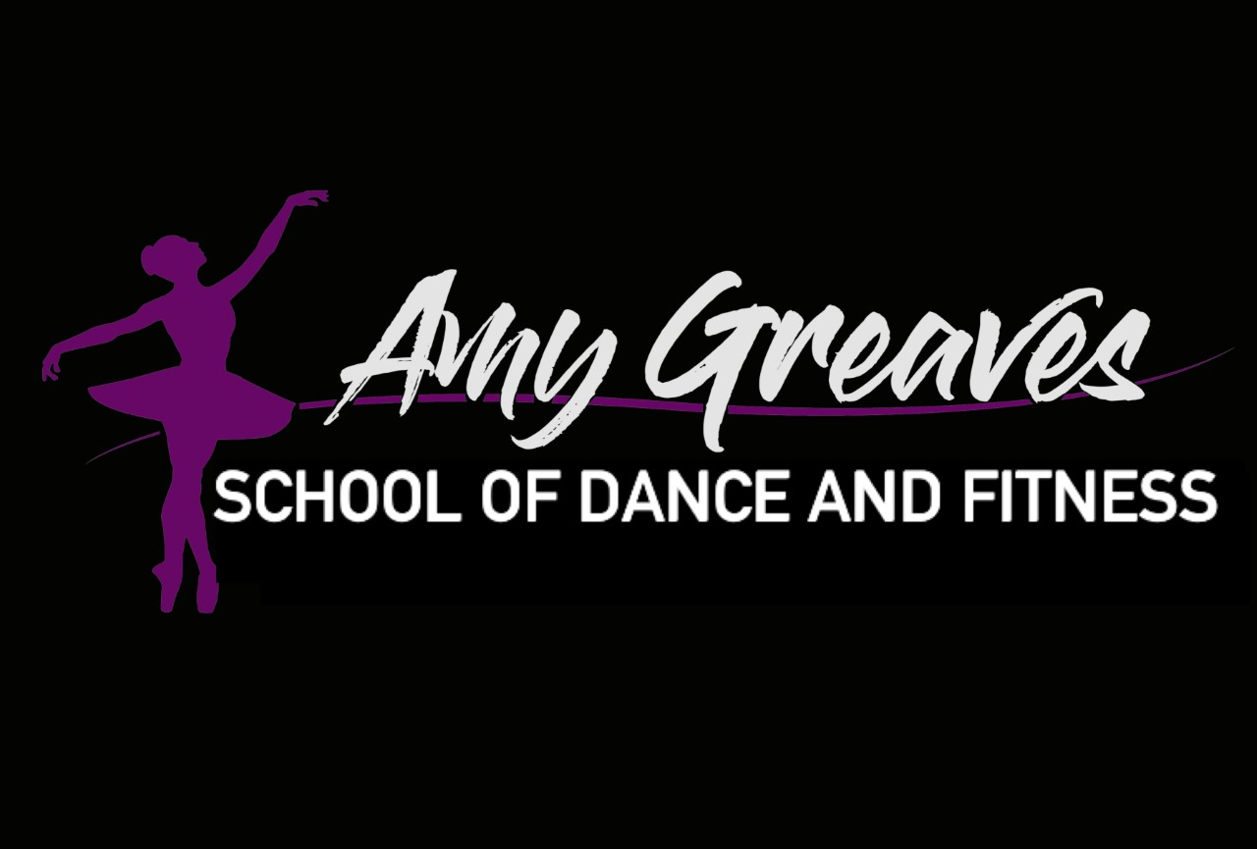

Amy Greaves School of Dance

Inclusion and diversity policy 2024 V.1

The Amy Greaves School of Dance is committed to fostering an inclusive and diverse environment where students, instructors, and staff of all backgrounds feel welcome, valued, and supported. This policy outlines our commitment to promoting inclusion and diversity in all aspects of our school operations, performances, and community interactions.

This policy applies to all students, instructors, staff, volunteers, parents and stakeholders of The Amy Greaves School of Dance.

#### **Principles**

1. **Equal Opportunity**: We provide equal opportunities to all students, instructors, and staff regardless of race, color, religion, gender, sexual orientation, gender identity or expression, national origin, age, disability, or any other characteristic protected by law.
2. **Inclusive Culture**: We strive to create a dance school culture that encourages and supports diversity and inclusion. This includes recognising and valuing different perspectives, backgrounds, and experiences in dance styles, techniques, and performances.
3. **Respect and Dignity**: Everyone at The Amy Greaves School of Dance is to be treated with respect and dignity. Harassment, bullying, or discrimination of any kind will not be tolerated.
4. **Accessibility**: We are committed to ensuring that our facilities, classes, and performances are accessible to all, including those with disabilities.
5. **Training and Development**: We will provide training and development opportunities to enhance understanding and appreciation of diversity and inclusion within the dance community.
6. **Recruitment and Retention**: We aim to attract, recruit, and retain a diverse body of students, instructors, and staff. Our recruitment processes are designed to identify and mitigate any potential biases.

#### **Responsibilities**

* **Leadership**: The leadership team, including the school principal, is responsible for championing diversity and inclusion within the school. They must ensure that this policy is effectively communicated and implemented.
* **Instructors and Staff**: All instructors and staff members are responsible for fostering an inclusive environment. This includes incorporating diverse perspectives and techniques in their teaching and interactions.
* **Students and Families**: Every student and their families are encouraged to contribute to an inclusive and respectful school community. This includes being open-minded, supportive, and participating in school activities that promote diversity.

#### **Implementation**

1. **Training**: Regular training sessions will be conducted to educate instructors, staff, and students about diversity and inclusion, unconscious bias, and respectful behavior.
2. **Inclusive Curriculum**: Develop and implement a dance curriculum that includes a wide range of dance styles and cultural perspectives to reflect the diversity of the dance community.
3. **Feedback and Reporting**: Establish clear channels for students, instructors, and staff to provide feedback or report concerns related to diversity and inclusion. Ensure that reports are handled confidentially and appropriately.
4. **Performance Opportunities**: Ensure that all students have equal access to performance opportunities, regardless of their background or level of experience.
5. **Communication**: Regularly communicate our commitment to diversity and inclusion to all members of the school community through various channels, including meetings, newsletters, and social media.
6. **Community Engagement**: Partner with local organisations and communities to promote diversity and inclusion in dance, including outreach programs and community performances.

This policy will be reviewed annually to ensure its effectiveness and relevance. Feedback from students, instructors, staff, and other stakeholders will be considered during the review process.

At The Amy Greaves School of Dance, we believe that diversity and inclusion are fundamental to the art of dance and our success as a school. We are committed to creating a welcoming and supportive environment where every individual feels valued and empowered to express themselves through dance. This policy is a testament to our dedication to fostering a diverse and inclusive dance community.