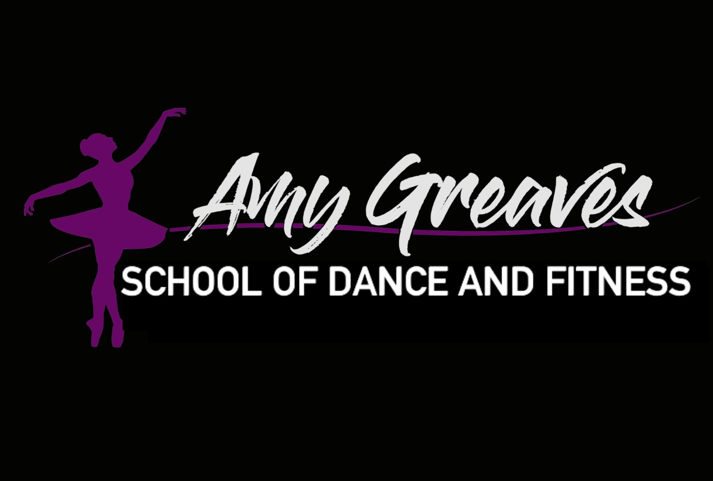

Amy Greaves School of Dance

Safe Touch Policy 2024 V.1

#### **Purpose**

The Safe Touch Policy is designed to create a secure, respectful, and professional environment for all students, instructors, and staff at The Amy Greaves School of Dance. It outlines appropriate physical interactions to ensure that everyone feels comfortable and safe during classes and performances.

#### **Scope**

This policy applies to all instructors, students, assistants, and staff members at The Amy Greaves School of Dance

#### **Guidelines for Safe Touch**

1. **Respect Personal Boundaries**
   * Always ask for consent before initiating any physical contact.
   * Be mindful of each student's comfort level with touch and respect their boundaries at all times.
2. **Appropriate Touch**
   * Touch should be limited to areas necessary for instruction and correction in dance technique.
   * Appropriate areas include shoulders, arms, hands, upper back, knees, and feet.
   * Avoid any contact with private areas (chest, groin, and buttocks).
3. **Instructional Touch**
   * When necessary, demonstrate corrections using clear verbal instructions first.
   * If physical guidance is required, explain the purpose of the touch and ask for the student's permission.
   * Use minimal and brief touch only as needed to correct posture, alignment, or movement.
4. **Professionalism**
   * Maintain a professional demeanor at all times.
   * Do not engage in any form of touch that could be misconstrued or inappropriate.
   * Refrain from any physical affection such as hugging or patting unless initiated by the student and deemed appropriate within the context.
5. **Student Comfort**
   * Encourage students to voice any discomfort or concerns regarding physical contact.
   * Provide alternative methods of correction for students who are uncomfortable with touch.
6. **Reporting Concerns**
   * Establish a clear and confidential process for reporting any concerns or incidents related to inappropriate touch.
   * Take all reports seriously and investigate promptly.
7. **Training**
   * Provide regular training for instructors and staff on appropriate touch, consent, and maintaining professional boundaries.
   * Include education on recognizing and addressing signs of discomfort in students.

#### **Implementation**

1. **Communication**
   * Clearly communicate the Safe Touch Policy to all students, parents, instructors, and staff.
   * Include the policy in registration materials, handbooks, and on the school’s website.
2. **Monitoring and Review**
   * Regularly review the policy to ensure its effectiveness and relevance.
   * Solicit feedback from students, parents, and staff to make necessary improvements.

#### **Conclusion**

The Amy Greaves School of Dance is committed to providing a safe and respectful environment for all participants. By adhering to this Safe Touch Policy, we aim to foster a positive and professional atmosphere where everyone can thrive and enjoy the art of dance.

.