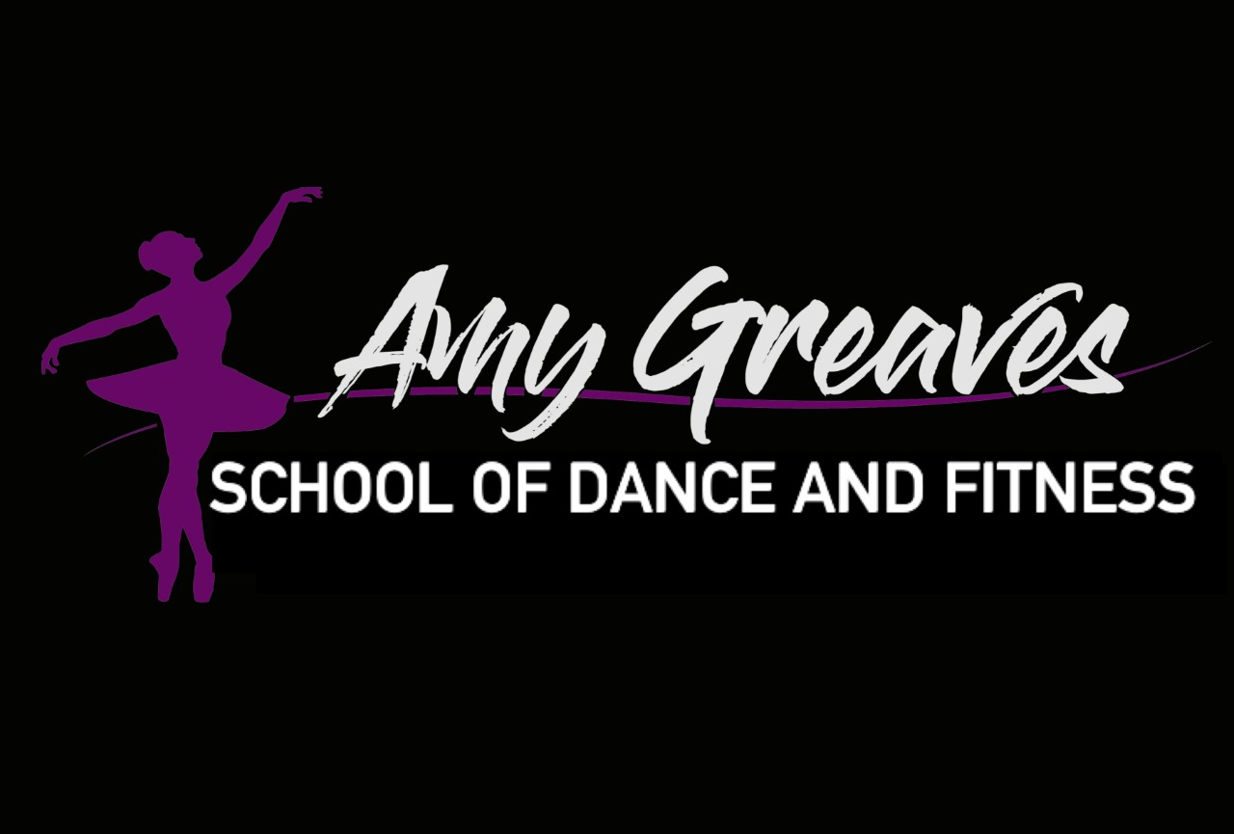

Amy Greaves School of Dance

Lock Down 2024 V.1

#### **Purpose**

The Lockdown Policy is designed to ensure the safety and security of students, instructors, staff, and visitors in the event of an emergency that requires securing the premises. This policy outlines the procedures to be followed during a lockdown to protect everyone on-site.

#### **Scope**

This policy applies to all students, instructors, assistants, staff members, and visitors at The Amy Greaves School of Dance.

#### **Definitions**

* **Lockdown**: A procedure used to secure the premises and protect individuals from a potential threat inside or near the facility.
* **Shelter-in-Place**: A directive to seek immediate shelter and remain there during an emergency rather than evacuating the building.

#### **Procedures**

1. **Initiating a Lockdown**
   * A lockdown will be initiated upon the detection of a potential threat within or near the dance school premises.
   * The decision to initiate a lockdown can be made by any staff member who becomes aware of the threat but must be communicated immediately to the director or the highest-ranking staff member present.
2. **Lockdown Notification**
   * Notification of a lockdown will be announced through the school's intercom system, alarm system, or by direct verbal communication.
   * The announcement will include the phrase “Lockdown, Lockdown, Lockdown” followed by brief instructions.
3. **During a Lockdown**
   * **Instructors and Assistants:**
     + Immediately stop all activities and instruct students to move to a designated safe area within the room away from doors and windows.
     + Lock all doors and windows.
     + Turn off lights and electronic devices that could reveal the room's occupancy.
     + Instruct students to remain silent and calm.
     + Do not open the door for anyone until an official “all clear” signal is given.
   * **Students:**
     + Follow the instructor’s directions quickly and quietly.
     + Move to the designated safe area and remain silent.
     + Turn off personal electronic devices.
   * **Staff Members:**
     + Ensure all common areas are cleared and locked down.
     + Assist with securing doors and windows in their vicinity.
4. **Communication**
   * Maintain silence and do not use mobile phones except to communicate critical information to emergency services if necessary.
   * Keep lines of communication open with local law enforcement and follow their directives.
5. **Emergency Services**
   * Upon initiation of a lockdown, emergency services will be contacted immediately by dialing 911.
   * Provide clear and concise information about the nature of the threat, location, and any relevant details.
6. **End of Lockdown**
   * The lockdown will remain in effect until an “all clear” signal is given by law enforcement or the dance school director.
   * The “all clear” signal will be communicated through the same channels used to initiate the lockdown.
   * Once the lockdown is lifted, conduct a headcount of all students and staff to ensure everyone’s safety.

#### **Post-Lockdown Procedures**

1. **Communication with Parents/Guardians**
   * Inform parents/guardians about the lockdown event as soon as it is safe to do so.
   * Provide details about the incident and the measures taken to ensure the safety of their children.
2. **Debriefing**
   * Conduct a debriefing session with all staff and students involved in the lockdown to discuss what happened and address any concerns or questions.
   * Provide access to counseling services if needed.
3. **Review and Update**
   * Review the lockdown procedures and the response to the incident.
   * Make any necessary updates to the policy and provide additional training to staff and students based on the lessons learned.

#### **Training**

* Conduct regular training sessions for all staff, instructors, and students on lockdown procedures.
* Include lockdown drills as part of the school's emergency preparedness program to ensure everyone knows their roles and responsibilities.

#### **Conclusion**

The safety and security of everyone at The Amy Greaves School of Dance are of paramount importance. By adhering to this Lockdown Policy, we aim to prepare for and effectively manage emergency situations, ensuring the well-being of our dance community.